

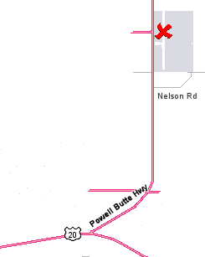










Aviation Day
Bend Municipal Airport
Scheduled Events

Saturday, June 11, 2005
7:30 a.m. to 4 p.m.

Location: Bend Airport
Directions: Head East on Highway 20 to
Powell Butte Highway. Turn left, and the
Bend Airport is 3 miles ahead on the right.
Overflow parking at Lancair on Nelson Road.

7:30 am-9 am Pancake Breakfast – hosted by EAA 617 - $5 all you can eat!
9:00 am Scenic Flights $25 – The Flight Shop (388-0019)
9:00 am-4pm Sign-up for future Young Eagles aviation events
9:00 am-4pm Static Aircraft Displays from
Vintage to the latest Lancair and Cessna
9:00 am-4pm Powered Parachutes, Gliders, Gyrocopters
9:00 am-4pm Motorcycle and Vintage car displays
9:00 am-4pm Air Life Open House
9:00 am-4pm Over 100 Model Airplanes
9:00 am-4pm U.S. Army – UH 60 Blackhawk
9:00 am-4pm U.S. Coast Guard – HH-65A Dolphin
9:15 am Glider Rides ($50)
9:45 am Glider Water Drop demonstration
10:00-am Hot Air Balloon demonstrations
10:00 am-4 pm Shuttle Service from Lancair to the Flight
Services Building.
12:00 pm Glider Water Drop Demonstration
12:15pm Model Airplane Demonstrations
4:00 pm Airport Festival Ends
6:00 pm Balloons Over Bend - Night Glow Festival
at The Shops in the Old Mill District

Scheduled Participants Include:
Air Life of Oregon, City of Bend, Civil Air Patrol, Electronics International, Experimental Aircraft Association Chapters 617 and 1345, High Desert Soaring Club, High Desert Flyers, High Mountain E&S, Lancair, Leading Edge Avionics, Oregon Pilots Association, Precise Flight, The Flight Shop, The Ninety-Nines, U.S. Forest Service, Windward Performance, and more...

Please visit our Web site for more details about
Bend Chamber Balloons Over Bend 2005: www.balloonsoverbend.com

